The Basics of Eye Anatomy
The eye is a complex optical system - very similar to a camera. Vision begins when light enters the eye through the cornea, a powerful focusing surface. From there, it travels through clear aqueous fluid, and passes through a small aperture called the pupil. As muscles in the iris relax or constrict, the pupil changes size to adjust the amount of light entering the eye. Light rays are focused through the lens, and proceed through a clear jelly-like substance in the center of the eye called vitreous, which gives it form and shape. When light rays finally land on the retina, the part of the eye similar to film in a camera, they form an upside-down image. The retina converts the image into an electrical impulse that travels along the optic nerve to the brain, where it is interpreted as an upright image.
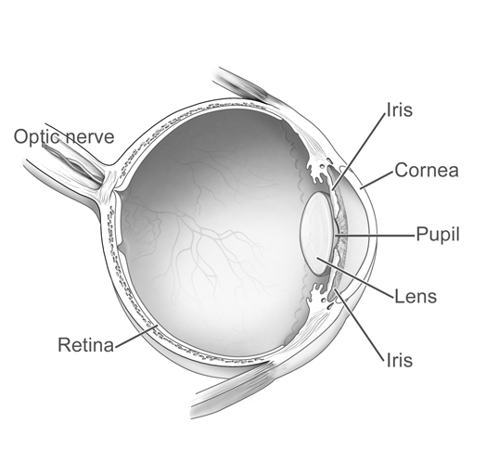

The Eye’s Essential Components
The ability to see is dependent on the actions of several structures in and around the eyeball. The graphic above lists many of the essential components of the eye's optical system. These include:
- Retina
- Iris
- Lens
- Pupil
- Cornea
- Optic Nerve
When you look at an object, light rays are reflected from the object to the cornea. The light rays are bent, refracted and focused by the cornea, lens, and vitreous. The job of the lens is to make sure the rays come to a sharp focus on the retina. The resulting image on the retina is upside-down. Here at the retina, the light rays are converted to electrical impulses which are then transmitted through the optic nerve, to the brain, where the image is translated and perceived in an upright position!

The Eye as a Camera
Think of the eye as a camera. A camera needs a lens and a film to produce an image. In the same way, the eyeball needs a lens (cornea, crystalline lens, vitreous) to refract, or focus the light and a film (retina) on which to focus the rays. If any one or more of these components is not functioning correctly, the result is a poor picture. The retina represents the film in our camera. It captures the image and sends it to the brain to be developed. The macula is the highly sensitive area of the retina. The macula is responsible for our critical focusing vision. It is the part of the retina most used. We use our macula to read or to stare intently at an object.

Macular Degeneration
Macular degeneration is a general term used to describe a number of diseases of the retina. Of these diseases, age-related macular degeneration is the most common, primarily affecting people over the age of 60. The www.macula.org website is intended to educate patients and their families about macular degeneration, its treatment and low vision rehabilitation.
With macular degeneration, a spot called a scotoma may appear in your central vision. This scotoma may look light, or dark, or blurred. Sometimes, part of an image may look wavy or distorted as the surface of the retina becomes uneven.
It occurs in:
- Primarily people over 60
  - Not related to x
  - Small but significant correlation to y
- No family component

Cataract

What is a cataract?
A cataract is a clouding of the lens in the eye that affects vision. Most cataracts are related to aging. Cataracts are very common in older people. By age 80, more than half of all Americans either have a cataract or have had cataract surgery. A cataract can occur in either or both eyes. It cannot spread from one eye to the other.

What is the lens?
The lens is a clear part of the eye that helps to focus light, or an image, on the retina. The retina is the light-sensitive tissue at the back of the eye. In a normal eye, light passes through the transparent lens to the retina. Once it reaches the retina, light is changed into nerve signals that are sent to the brain. The lens must be clear for the retina to receive a sharp image. If the lens is cloudy from a cataract, the image you see will be blurred.

Are there other types of cataract?
Yes. Although most cataracts are related to aging, there are other types of cataract:
Secondary cataract | Cataracts can form after surgery for other eye problems, such as glaucoma. Cataracts also can develop in people who have other health problems, such as diabetes. Cataracts are sometimes linked to steroid use.
Traumatic cataract | Cataracts can develop after an eye injury, sometimes years later.
Congenital cataract | Some babies are born with cataracts or develop them in childhood, often in both eyes. These cataracts may be so small that they do not affect vision. If they do, the lenses may need to be removed
Radiation cataract | Cataracts can develop after exposure to some types of radiation

